CS624 Full-Stack Development Mobile App
PE03 – todos
School of Technology & Computing (STC)
City University of Seattle (CityU)

Before You Start
- You already created a private GitHub repository for all your programming exercises, “cs624-pe-your_first_name.”
- You allowed your instructor and the Teaching Assistant to access your GitHub repository for programming assignments.
- The GitHub Codespaces may bill your account according to your usage. Check the price at https://docs.github.com/en/billing/managing-billing-for-github-codespaces/about-billing-for-github-codespaces.
- Some steps are not explained in the assignment. If you are not sure what to do:
  - Consult the resources listed in your course.
  - If you need help solving the problem after a few tries (~15 minutes), ask a TA for help.

Learning Outcomes
Students will be able to:
- Finish working on building their first React native app “todos”.

Note: This PE consists of two parts. The first part should be completed after completing the HOS03. Second part of this PE should be completed only after finishing the HOS04.

Problem: Part 1
- Create a new folder in your PE directory with the name PE03-todos and copy the contents of the todos app created in HOS03 to PE03-todos. For copying the application “todos” from HOS03 to PE03, visit the CS 624 Repository for Examples. You can find the CopyRepo guideline under Module03.
- Please note this part of the PE is continuation of HOS03. Make sure you have a working app from HOS03 before starting this exercise.
- For this part of the exercise, you will add the functionality to add the items to a list of to-dos. You will create a button and by click of that button should add the new to-do to the array of to-dos.
- The App UI should look something like this.
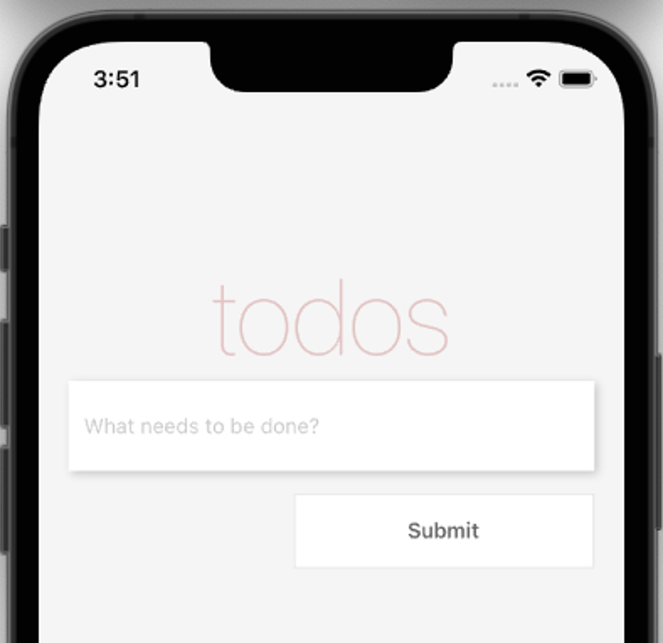

- Also, you need to log the items you are adding to the array in the terminal. For example, I have added few tasks, and this is the output of my terminal on GitHub codespace.
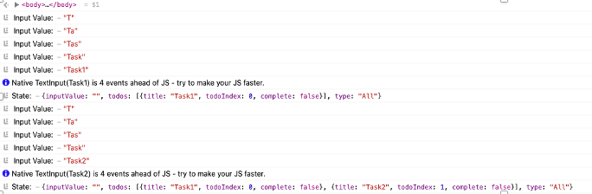
- Save your App UI and console screenshots from your mobile under this PE folder.
- To complete these tasks, you may refer Listings 3.10 to 3.13 in the chapter 3 of the textbook, Dabit, N. (2019). React Native in Action. Manning Publications. (ISBN 9781617294051)

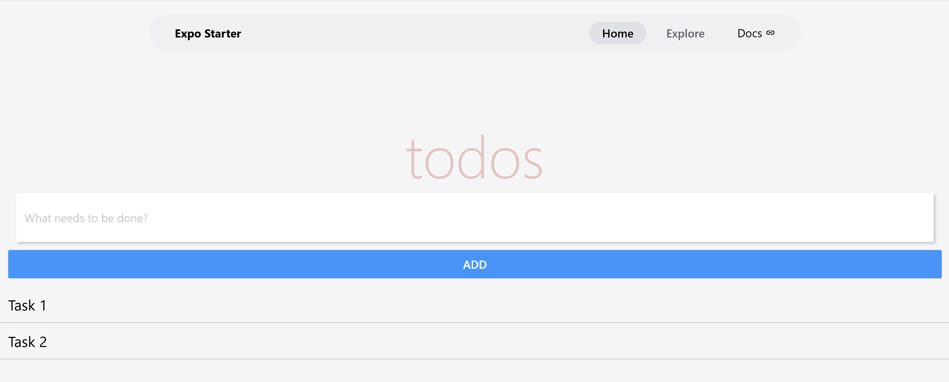

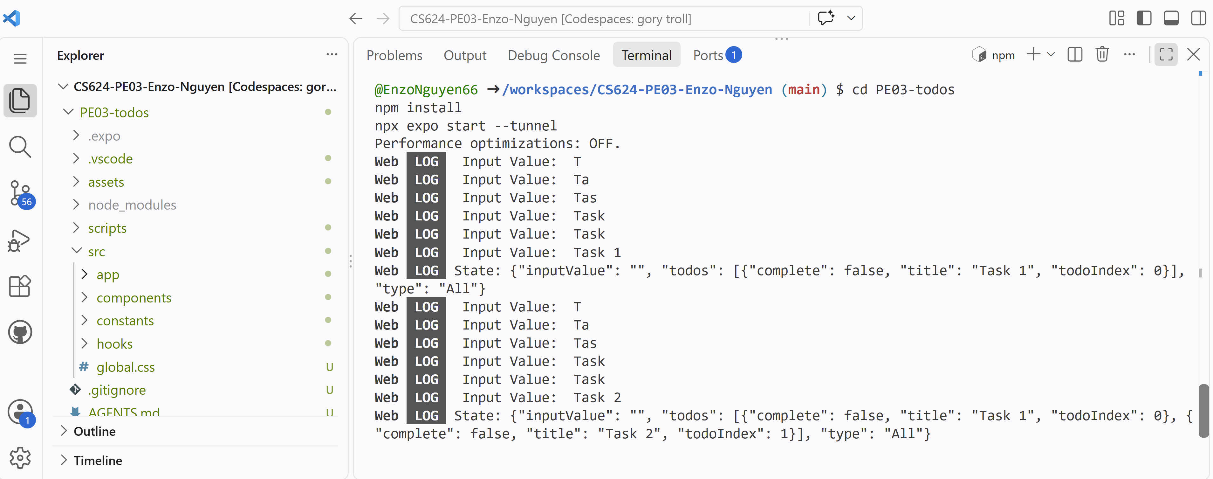
Problem: Part 2
- Please note this part of the PE is continuation of HOS04. Make sure you have a working app from HOS04 before starting this exercise.
- Copy the contents of the to-do app from HOS04 to your PE03-todos folder to continue working on the app. For copying the application “todos” from HOS03 to PE03, visit the CS 624 Repository for Examples. You can find the CopyRepo guideline under Module03.
- For this part of the exercise, you will build a tab bar filter show either all todos, only completed todos or the incomplete todos.
- The UI of the App should look like the below image on you finish the implementation.
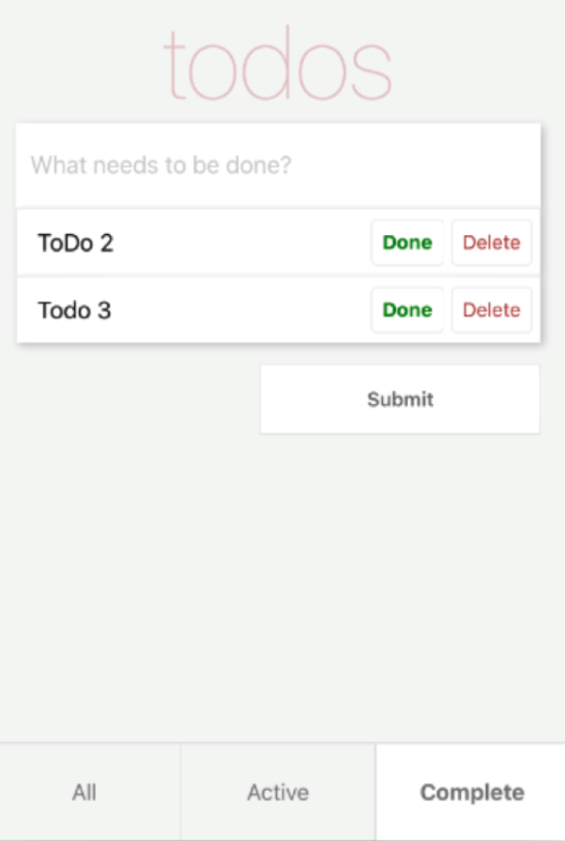
- Save your App UI and console screenshots from your mobile under this PE folder.
- To complete these tasks, you may refer Listings 3.22 to 3.26 in the chapter 3 of the textbook, Dabit, N. (2019). React Native in Action. Manning Publications. (ISBN 9781617294051)

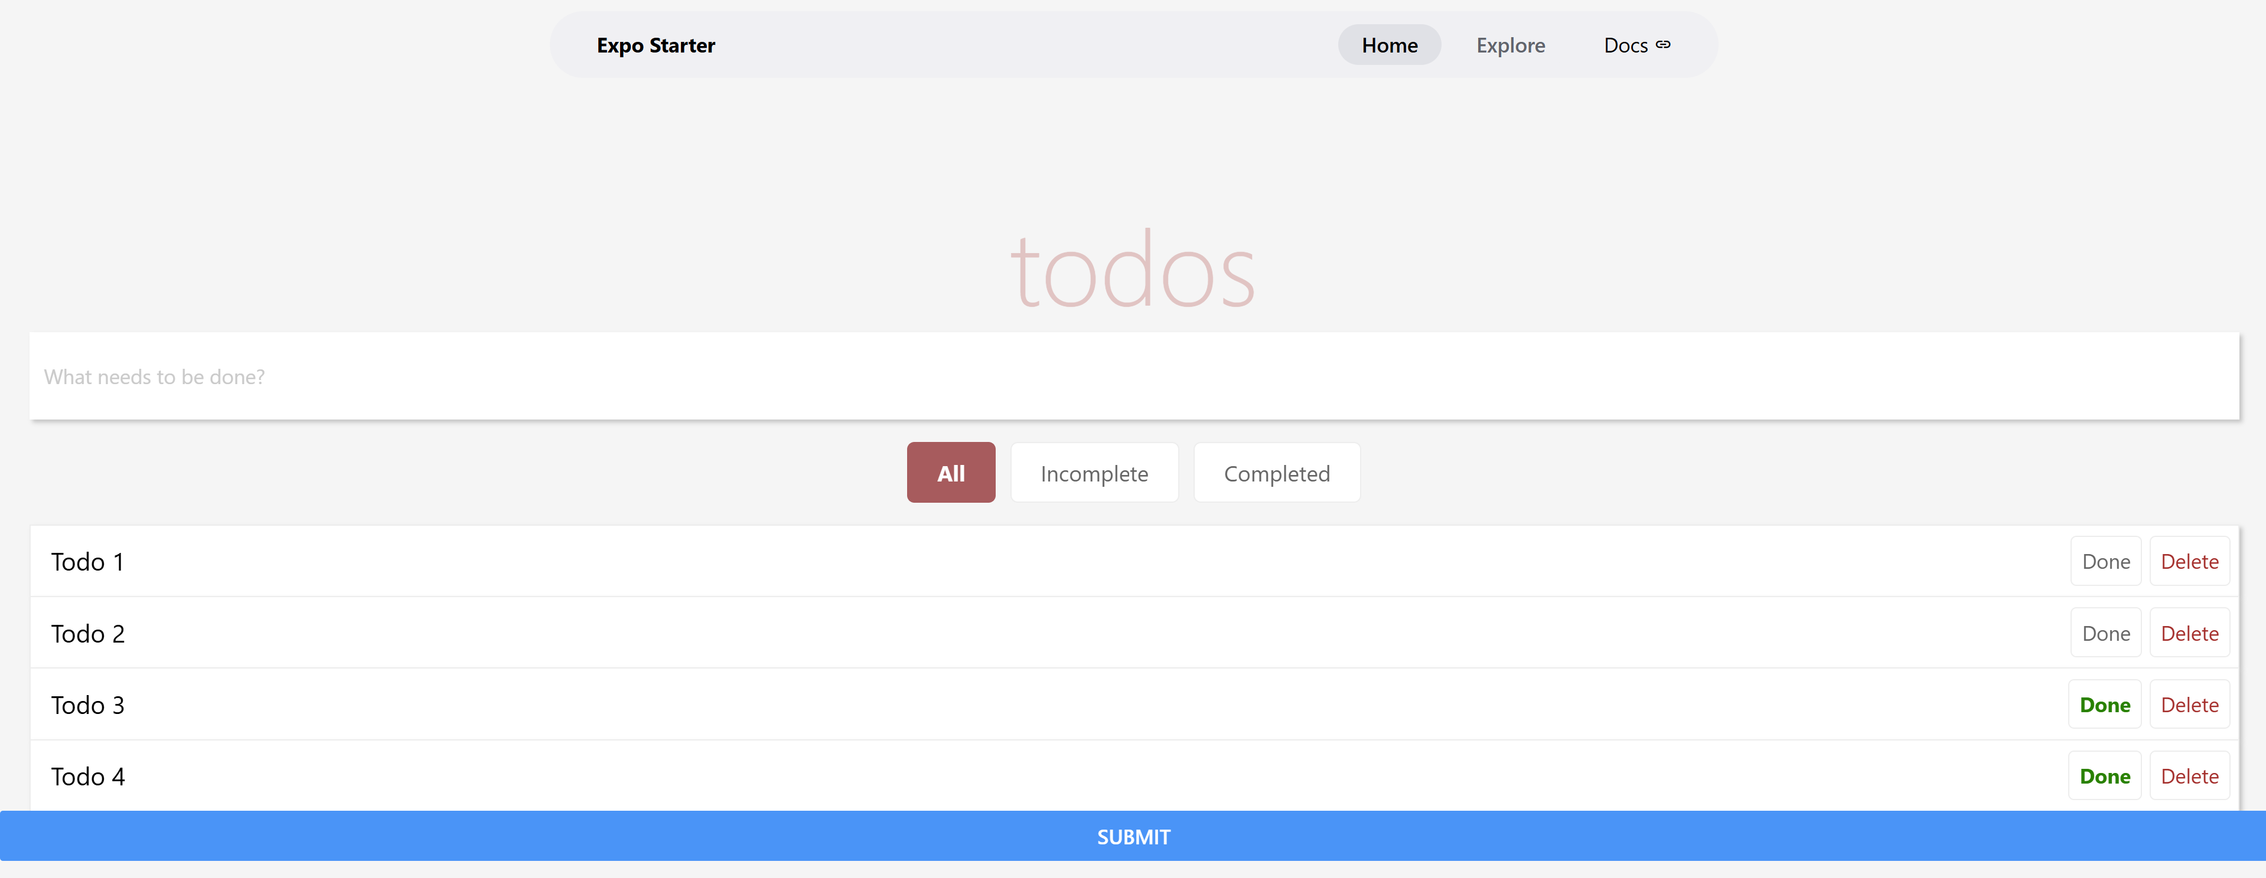

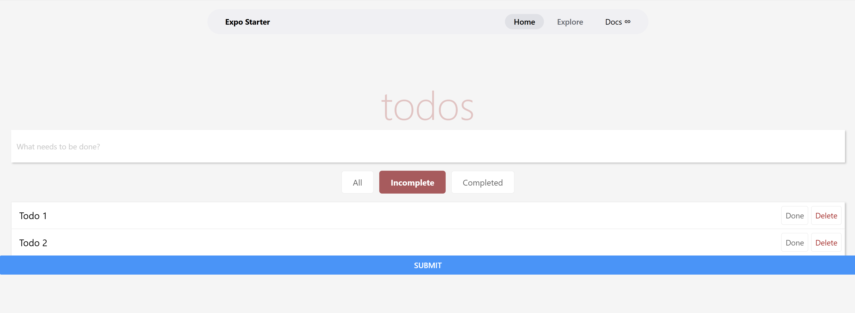
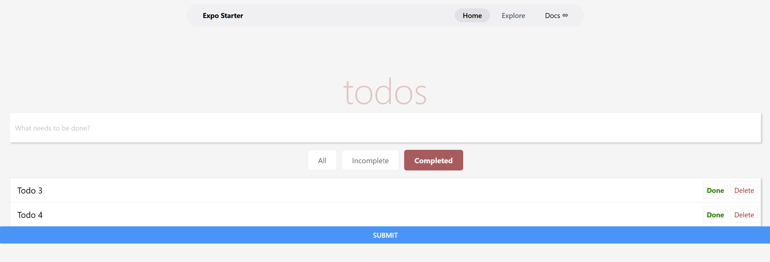

Submission
- If you already created a GitHub repository for your programming exercises, “cs624-pe-your_first_name,” create a directory for programming exercise 3, “PE03-todos.”
- Finish your programming exercise under the PE03 directory.
- Write a 150-word analysis report to explain how the program works in README.md regarding your understanding of the tasks in this assignment. The README.md has three level-1 headings – Input, Process, and Output.
- Submit the link of your GitHub repository to your course shell through your assignment submission.

